**-- Task 1 : Creating roles**

use role securityadmin;

create or replace role admin;

grant role admin to role accountadmin;

create or replace role PII;

grant role PII to role accountadmin;

create or replace role developer;

grant role developer to role admin;

----- Granting permissions to admin role for creating database and schemas

use role securityadmin;

grant role admin to user supriyaneela;

grant usage on warehouse assignment_wh to role admin;

grant operate on warehouse assignment_wh to role admin;

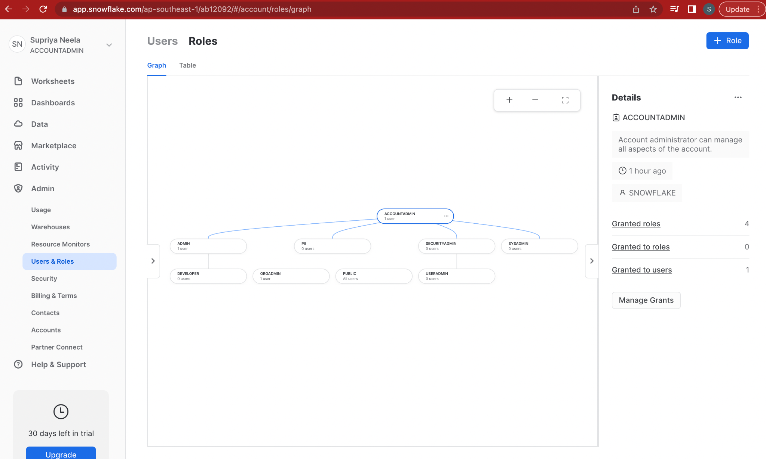

**-- Task 2 :Created warehouse assignment_wh and granted access**

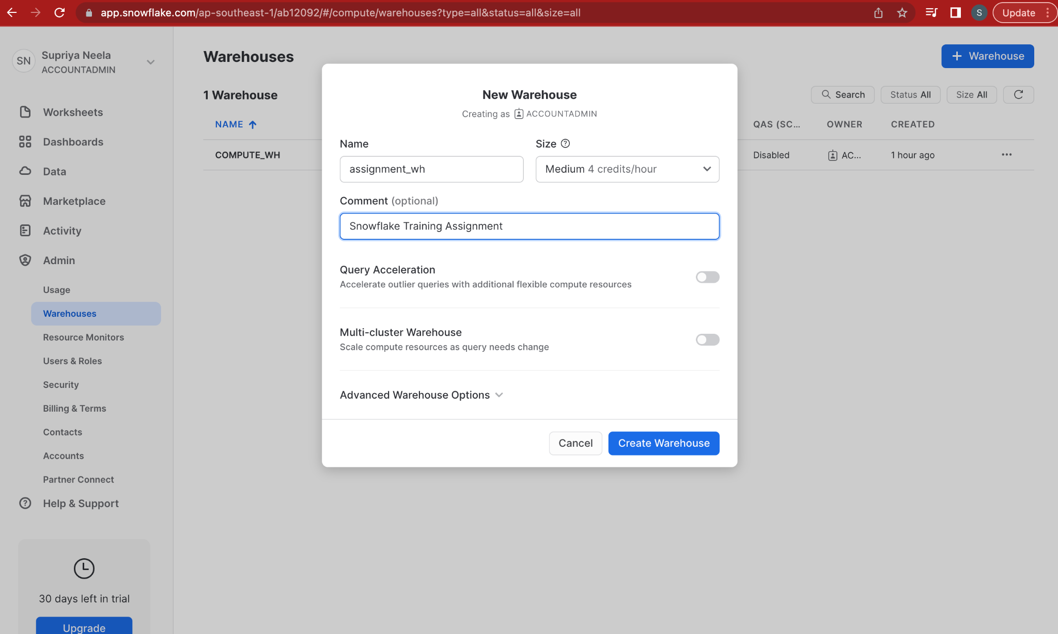

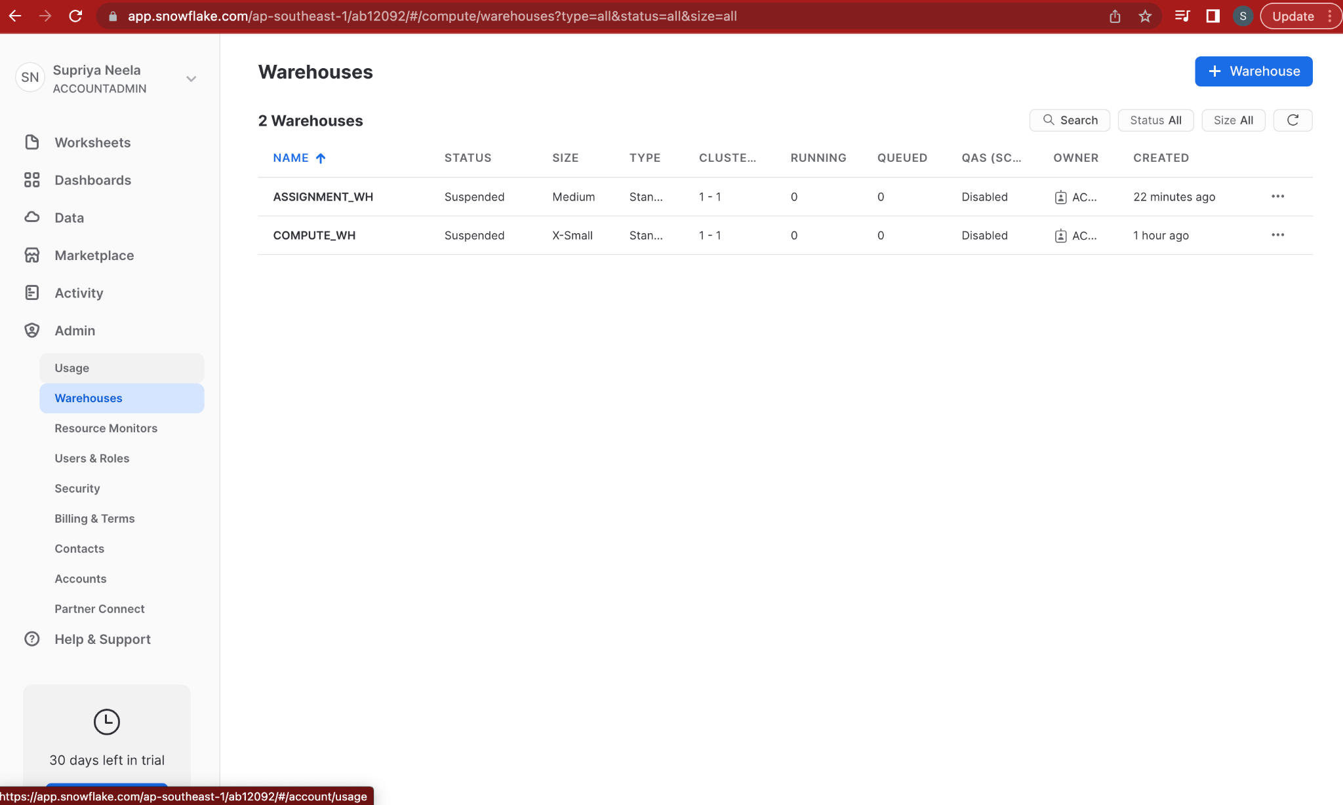

**-- Task 3 : Switched to admin account**

use role sysadmin;

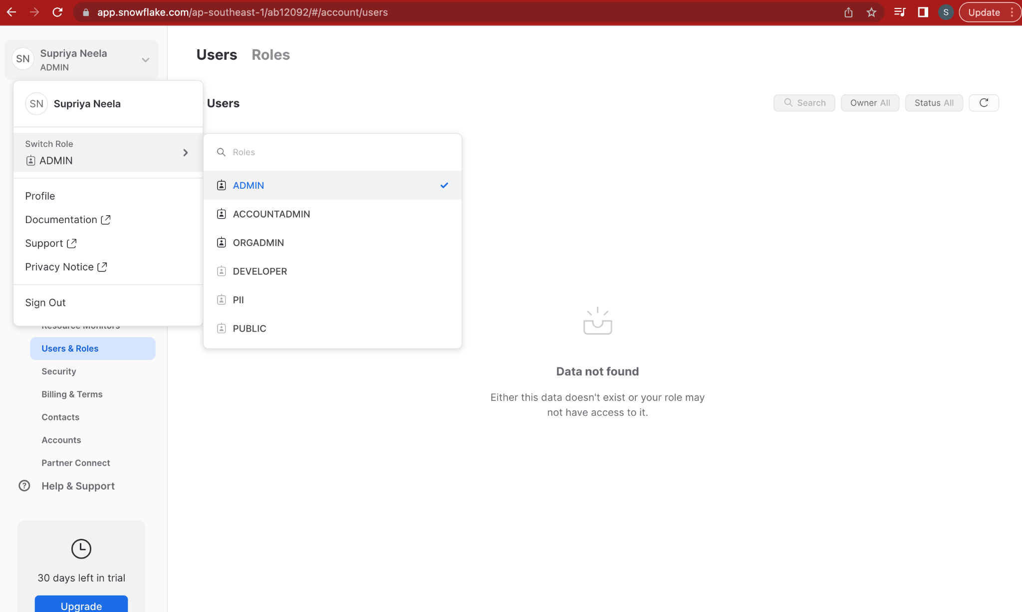

**-- Task 4 : Create database assignment_db**

grant create database on account to role admin;

use role admin;

use warehouse assignment_wh;

create or replace database assignment_db;

use database assignment_db;

**-- Task 5 : Create a schema my_schema**

create or replace schema my_schema;

use schema my_schema;

**-- Task 6 : Create sample employee table with audit columns elt_ts,elt_by,file_name**

create or replace table employees(

EMPLOYEE_ID integer PRIMARY KEY,

FIRST_NAME string,

LAST_NAME string,

EMAIL string,

PHONE_NUMBER string,

HIRE_DATE string,

JOB_ID string,

SALARY integer,

MANAGER_ID integer,

DEPARTMENT_ID integer,

elt_ts timestamp,

elt_by string,

file_name string

);

**--Task 7 : Create a variant of Employees table**

create or replace table employeesVariant(

EMPLOYEE_ID integer PRIMARY KEY,

FIRST_NAME string,

LAST_NAME string,

EMAIL string,

PHONE_NUMBER string,

HIRE_DATE string,

JOB_ID string,

SALARY integer,

MANAGER_ID integer,

DEPARTMENT_ID integer,

elt_ts timestamp,

elt_by string,

file_name string

);

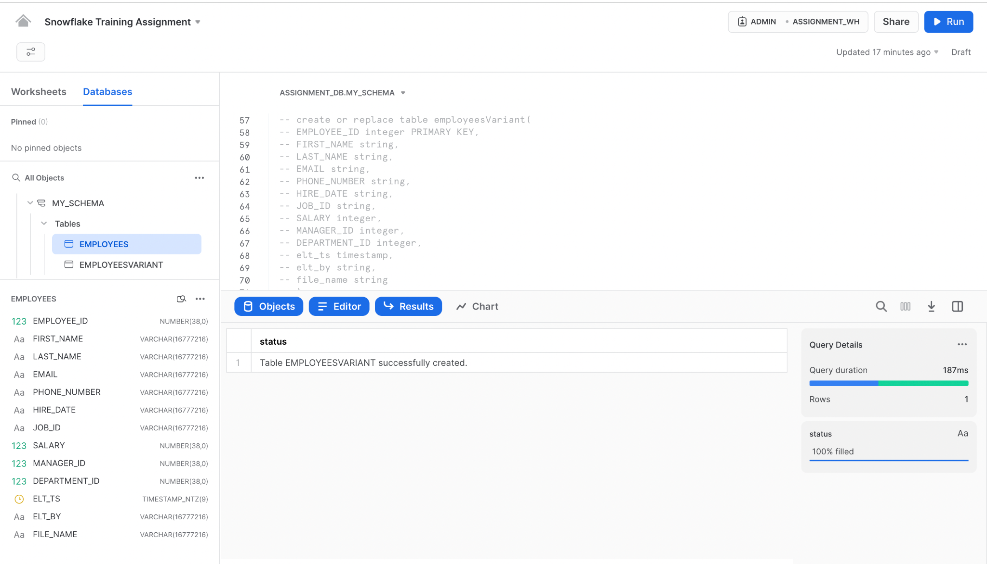

**-- Task 8 : Load the file into an external and internal stage**

create or replace file format r_csv

TYPE = "CSV"

COMPRESSION = "GZIP"

FILE_EXTENSION= 'csv.gz'

SKIP_HEADER = 1

ERROR_ON_COLUMN_COUNT_MISMATCH=FALSE

EMPTY_FIELD_AS_NULL = TRUE;

create or replace stage internal_stage file_format='r_csv';

create or replace stage external_stage

**-- Loading through internal stage**

**On local terminal execute ->** put file:///Users/saisupriya/Desktop/employee.csv @internal_stage;

copy into employees from

(SELECT $1,$2,$3,$4,$5,$6,$7,$8,$10,$11,

CURRENT_TIMESTAMP,

to_varchar('local'),

to_varchar('employees.csv') from @internal_stage

)

file_format = (format_name = 'r_csv')

on_error = continue;

select * from employees;

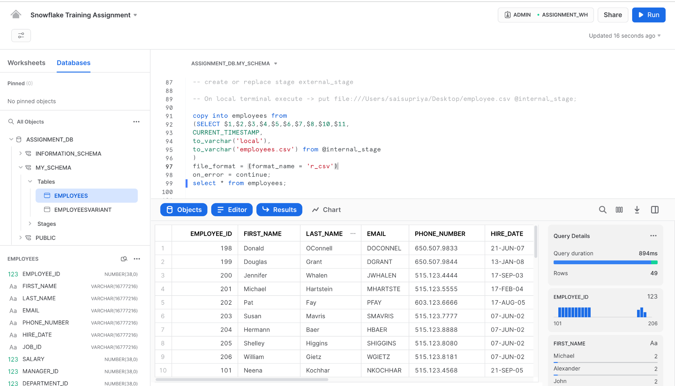

**-- Loading through external stage**

1.Uploaded employee.csv file to aws S3 Bucket

2.Edited bucket policy

{

"Version": "2012-10-17",

"Id": "Policy1665674245003",

"Statement": [

{

"Sid": "Stmt1665674243203",

"Effect": "Allow",

"Principal": "*",

"Action": "s3:GetObject",

"Resource": "arn:aws:s3:::snowflake-ass/*"

}

]

}

create or replace stage external_stage url='s3://snowflake-ass/';

copy into employeesVariant from

(SELECT $1,$2,$3,$4,$5,$6,$7,$8,$10,$11,CURRENT_TIMESTAMP,

to_varchar('AWS S3'),

to_varchar('employees.csv')

from @external_stage)

file_format = (type = csv field_delimiter = ',' skip_header = 1)

on_error = continue;

select * from employeesVariant;

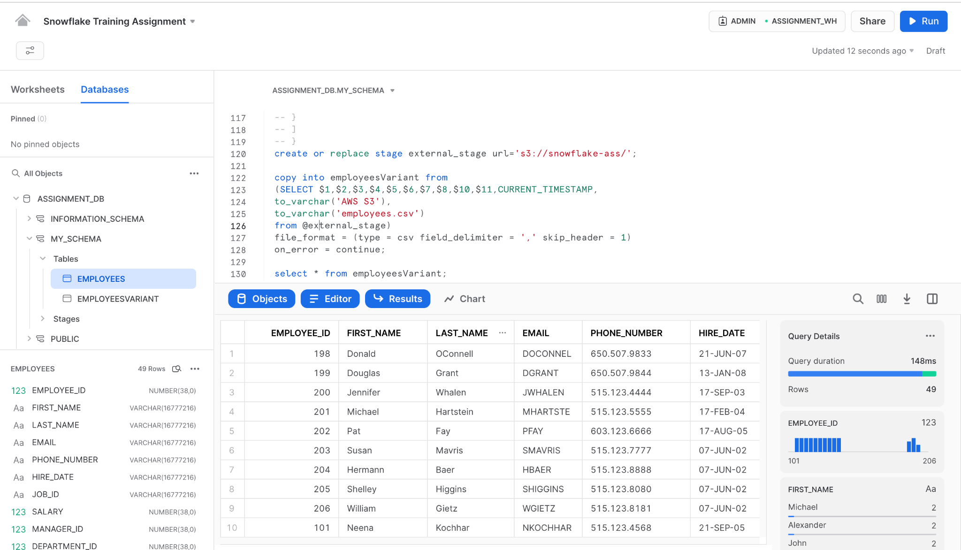

**--- Task 10 Upload any unrelated parquet file to the stage location and infer the schema of the file.**

create or replace file format parquet_format type = 'parquet';

create or replace stage parquet_stage file_format = parquet_format;

**On terminal ->** put file:///Users/saisupriya/Downloads/snowflake_assignment.parquet @parquet_stage;

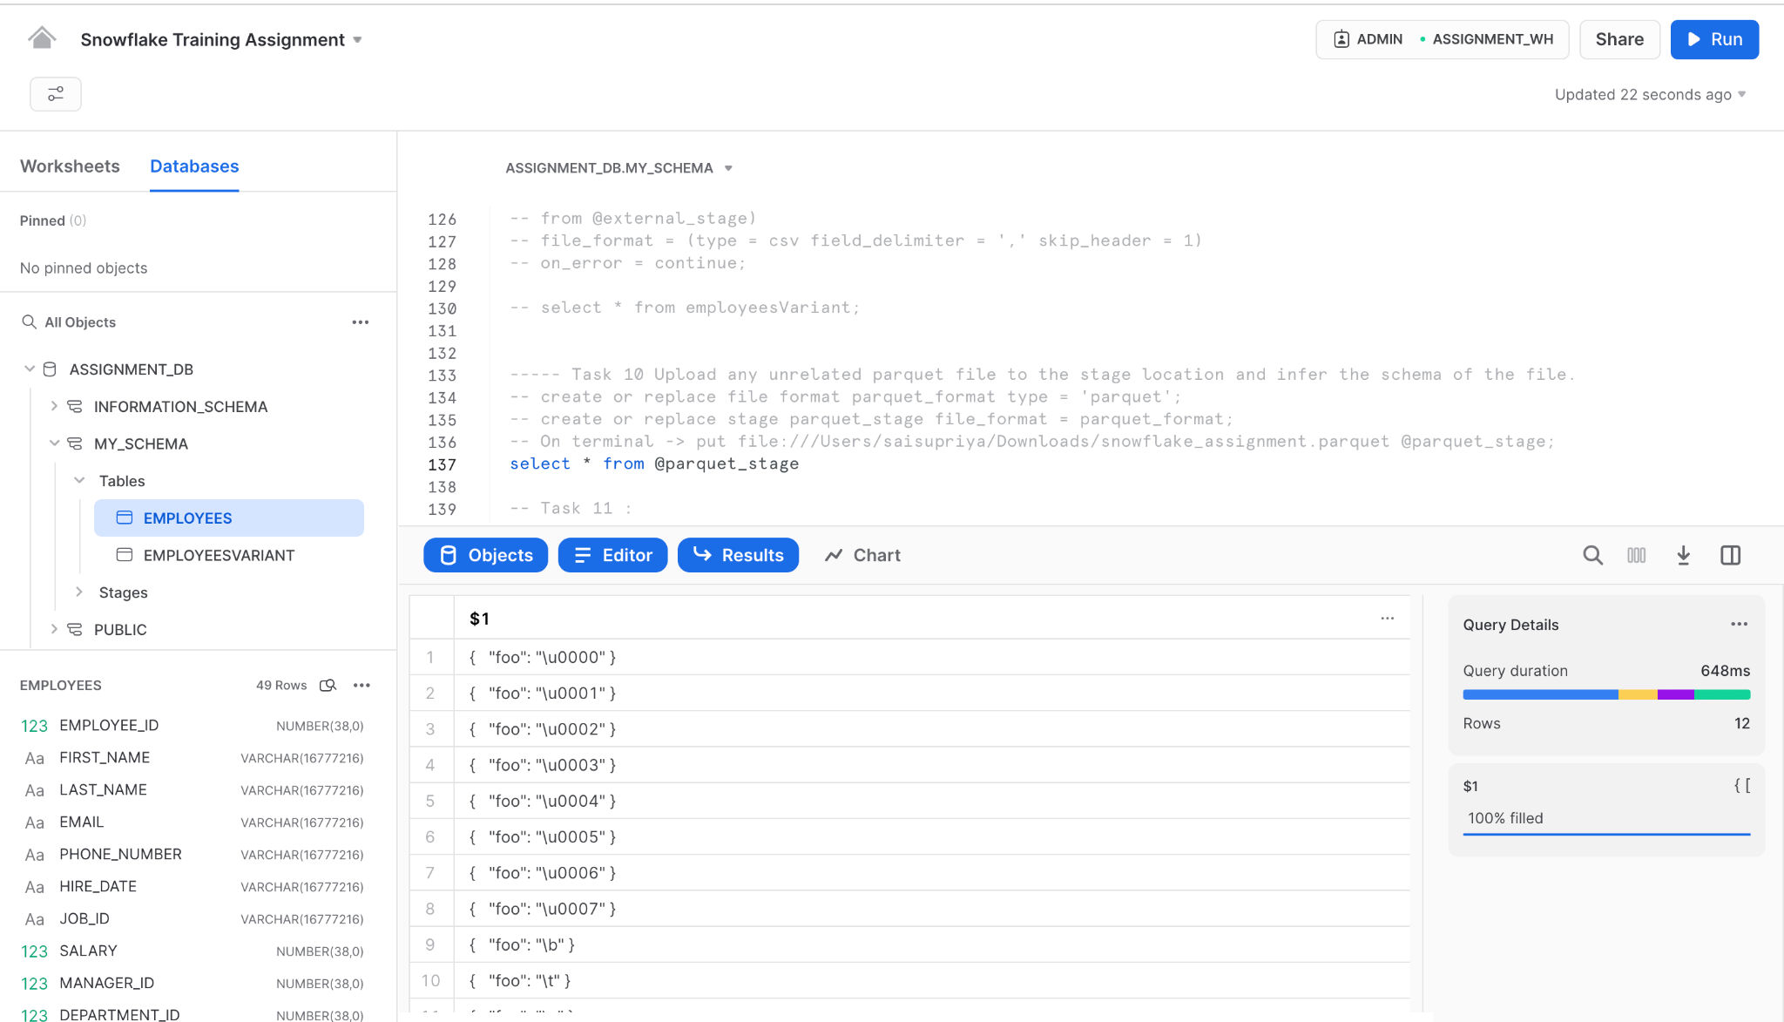

**-- Task 11 : Run a select query on the staged parquet file without loading it to a snowflake table.**

select $1:foo from @parquet_stage/snowflake_assignment.parquet

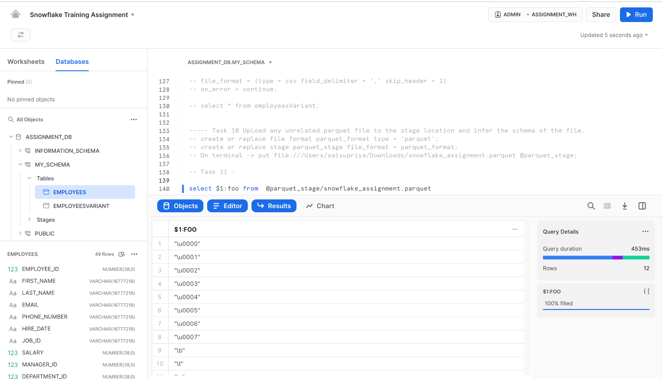

**-- Task 12 : Masking Policy : If the role is PII the value of these columns should be visible.**

**Granting privileges for developer and PII roles**

use role securityadmin;

grant usage on database assignment_db to role developer;

grant usage on schema assignment_db.my_schema to role developer;

grant usage on database assignment_db to role PII;

grant usage on schema assignment_db.my_schema to role PII;

grant select on all tables in schema assignment_db.my_schema to role developer;

grant select on all tables in schema assignment_db.my_schema to role PII;

grant usage on warehouse assignment_wh to role PII;

grant operate on warehouse assignment_wh to role PII;

**Before masking all the details are visible to PII and developer**

use role admin;

use schema my_schema;

create or replace masking policy PII_email as (email string) returns string ->

case

when current_role() in ('PII') then email

else '*********'

end;

create or replace masking policy PII_phone_number as (phone_number string) returns

string ->

case

when current_role() in ('PII') then phone_number

else '*********'

end;

alter table if exists my_schema.employees modify column email set masking policy

PII_email;

alter table if exists my_schema.employees modify column phone_number set masking

policy PII_phone_number;

use role PII;

select * from employees;

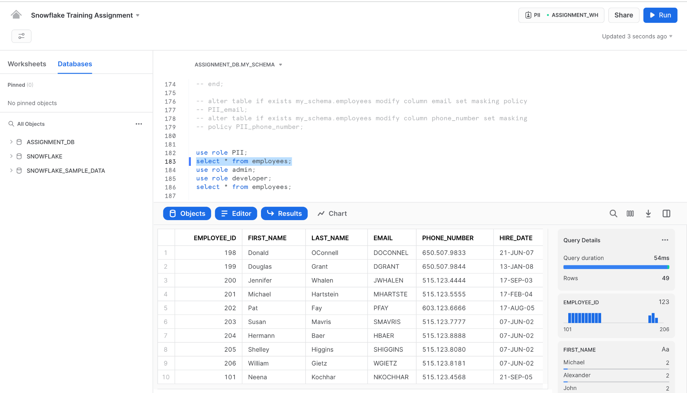

use role admin;

use role developer;

select * from employees;

